# RAJALAKSHMI ENGINEERING COLLEGE

RAJALAKSHMI NA ANDALAM — 602 105

RAJALAKSHMI

ENGINEERING COLLEGE

Laboratory Observation NoteBook

CS23A34

USER INTERFACE AND DESIGN LAB

Name : SURYA E

Year/Branch/Section : II/CSE/D Register No. :230701353

Semester : IV Academic Year: 2024-

25

Ex. No.4.b RegisteNo:

230701353 Name:SURYA E

Conduct task analysis for an app (e.g., online shopping) and document user flows. Create corresponding wireframes using dia

AIM:

The aim is to perform task analysis for an app, such as online shopping, document user flows, and create corresponding wireframes using Dia.

PROCEDURE: Tool link:

<http://dia-installer.de/> 1. Install Dia:

o d2ewnload Dia from the official website (<http://dia-installer.de/)> Install Dia on your computer

Open Dia:

## Launch the Dia application.

1. Create New Diagram:

o Go to File -> New Diagram.

O Select Flowchart as the diagram type.

1. Add Shapes:

O Use the shape tools (rectangles, ellipses, etc.) to create wireframes for each screen.

# n For example:

## n Home Page: Rectangle

u Product Categories: Rectangle u Product Listings: Rectangle

u Product Details: Rectangle

## u Cart: Rectangle

u Checkout: Rectangle

u Order Confirmation: Rectangle u Order History: Rectangle

1. Connect Shapes:

O Use the line tool to connect shapes, representing the user flows.

u For example:

u Home Page -> Product Categories

u Product Categories -+ Product Listings

z Product Listings -*• Product Details

## n Product Details -> Cart

n Cart -> Checkout

u Checkout -> Order Confirmation

u Order Confirmation -> Order History

1. Label Shapes:

O Double-click on each shape to add labels. M For example:

M Label the rectangle as "Home Page", "Categories",

"Product Listings", "Product Detailst t Cart" ltCheckoutt "Order Confirmation", "Order History".

1. Save the Diagram:

## *O* Go to File -> Save As.

O Save the diagram with a meaningful name, such as "Online Shopping App User Flows".

OUTPUT:

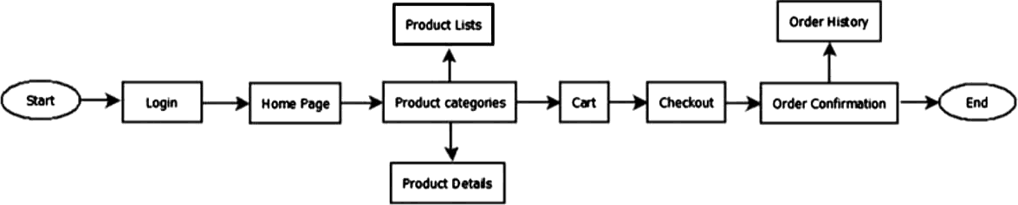

RESULT: Hence, to perform task analysis for an app, such as online

shopping, document user flows, and create corresponding wireframes using Dia has been successfully executed.